**곱집합 테이블 결합**

1. **Select * from sample72_x;**
2. **Select * from sample72_y;**
3. **Select * from sample72_x, sample72_y;**

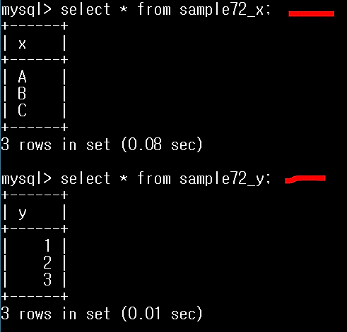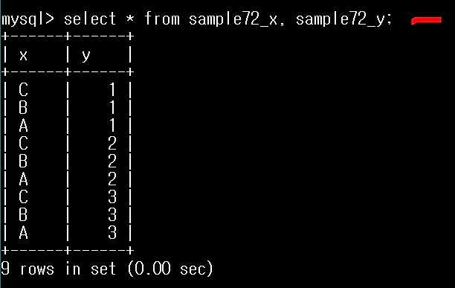

|  |  |  |  |  |  |  |
| --- | --- | --- | --- | --- | --- | --- |
| **X** |  | **Y** |  | **곱집합** | | |
| **A** |  | **1** |  | **A,1** | **A,2** | **A,3** |
| **B** | **X** | **2** | **=** | **B,1** | **B,2** | **B,3** |
| **C** |  | **3** |  | **C,1** | **C,2** | **C,3** |

**From 구에서 복수의 테이블을 지정하면**

**교차결합을 한다 (곱집합)**